***Assignment module 1***

Que.> What is SDLC ?

ANS > SDLC is structure imposed on the development of a software product

that defines the process for planning , implementation , tasting ,

documentation , deployment , and ongoing maintenance and support.

Que.> What is agile methodology ?

ANS > Agile SDLC model is combination of iterative and incremental process

Models with focus on process adaptability and customer satisfaction

by rapid delivery of working software product .

Que.> What is SRS ?

ANS > SRS is Software Requirements Specification .

Que.> what is oops ?

ANS > Object Oriented programing , The main aim of oop is to bind together

the data and the function that operate on them so that no other part of

the code can access this data except this function .

Que.> Write Basic Concept of oops

ANS > 1. Object

2. Class

3. Encapsulation

4. Abstraction

5. Inheritance

6. Polymorphism : - overriding , overloading

Que.> what is object ?

ANS > When a class is defined no memory is allocated but when it is instantiated memory is allocated.

Que.> What is class ?

ANS > It is a user defined data type which holds its own data member and member function .

Que.>What is encapsulation ?

ANS > encapsulation is defined as binding together the data and function that manipulates them .

Que. > What is inheritance ?

ANS > The capability of a class to derive properties and characteristics from another class is called inheritance .

Que. > What is polymorphism ?

ANS > Polymorphism defined as the ability of a message to be displayed in more than one form .

Que.> What is RDBMS

ANS > Relational Database Management System . RDBMS is basis of SQL and for all modern database system like MS SQL Server , IBM DB2, Oracle, MySQL and Microsoft Access.

Que. > What is SQL ?

ANS > SQL is Structured Query Language , which is a computer language for storing , manipulating and retrieving data stored in relational database.

Que. > write SQL commands …

ANS >  1. DDL :- Data Definition language

             2. DML :-Data Manipulation Language

             3. DCL :- Data control language

             4. DQL :- Data query language

Que. > Write SDLC phases with basic introduction.

ANS >  1> Requirement Gathering

∙ Features ∙ Usage scenarios ∙ Although requirements may be documented in written form, they may be incomplete, unambiguous, or even incorrect. ∙ Requirements will Change! ∙ Inadequately captured or expressed in the first place ∙ User and business needs change during the project

->  Three types of problems can arise:-

∙ Lack of clarity: It is hard to write documents that are both precise and easy to read.

∙ Requirements confusion: Functional and Non-functional requirements tend to be intertwined.

∙ Requirements Amalgamation: Several different requirements may be expressed together.

-> Types of Requirements:-

(1)Functional Requirements: describe system services or functions.

∙ Compute sales tax on a purchase

∙ Update the database on the server

(2) Non-Functional Requirements: are constraints on the system or the development process.

2 > Analysis Phase

∙ The analysis phase defines the requirements of the system, independent of how these requirements will be accomplished.

∙ This phase defines the problem that the customer is trying to solve.

∙ This analysis represents the “what” phase.

∙ This phase starts with the requirement document delivered by the requirement phase and maps the requirements into architecture.

3 > Design Phase

∙ Design Architecture Document

 ∙ Implementation Plan

∙ Critical Priority Analysis

∙ Performance Analysis

 ∙ Test Plan

 ∙ The Design team can now expand upon the information established in the requirement document.

4 > Implementation Phase

∙ In the implementation phase, the team builds the components either from scratch or by composition.

 ∙ Given the architecture document from the design phase and the requirement document from the analysis phase, the team should build exactly what has been requested, though there is still room for innovation and flexibility.

 ∙ For example, a component may be narrowly designed for this particular system, or the component may be made more general to satisfy a reusability guideline.

∙ Implementation – Code

 ∙ Critical Error Removal

5 > Testing Phase

 ∙ Simply stated, quality is very important. Many companies have not learned that quality is important and deliver more claimed functionality but at a lower quality level.

 ∙ It is much easier to explain to a customer why there is a missing feature than to explain to a customer why the product lacks quality.

 ∙ A customer satisfied with the quality of a product will remain loyal and wait for new functionality in the next version.

∙ Quality is a distinguishing attribute of a system indicating the degree of excellence.

 ∙ Regression Testing

 ∙ Internal Testing

 ∙ Unit Testing

 ∙ Application Testing

 ∙ Stress Testing

6 > Maintenance Phase

 ∙ Software maintenance is one of the activities in software engineering, and is the process of enhancing and optimizing deployed software (software release), as well as fixing defects.

- Corrective maintenance: identifying and repairing defects

- Adaptive maintenance: adapting the existing solution to the new platforms.

- Perfective Maintenance: implementing the new requirements .

Que. > Explain phases of waterfall model .

ANS > 1> Requirement Gathering

- Features

- Usage scenarios

- product objective

- documenting the requirement

2 > Analysis Phase

- This analysis represents the “what” phase.

-The analysis phase defines the requirements of the system, independent of how these requirements will be accomplished.

 3 > Design Phase

∙ Design Architecture Document

 ∙ Implementation Plan

∙ Critical Priority Analysis

∙ Performance Analysis

 ∙ Test Plan

 ∙ The Design team can now expand upon the information established in the requirement document.

4 > Implementation Phase

∙ In the implementation phase, the team builds the components either from scratch or by composition.

∙ Implementation – Code

5 > Testing Phase

-  This phase is check or test the every component of system . This phase is start after implementation phase.

6 > Maintenance Phase

 ∙ Software maintenance is one of the activities in software engineering, and is the process of enhancing and optimizing deployed software (software release), as well as fixing defects.

Que.> Write phases of spiral model

ANS >  1) planning :- determination of objectives , alternatives and constraints

             2) Risk Analysis :- Analysis of alternatives and identification/ resolution risk

             3)Engineering :- Development of the “next level” product

             4) Customer Evolution:- Assessment of results of engineering

Que.> Write agile manifesto principles..

ANS >  (1) Individuals and Interactions :-  In agile model self organization and motivation are important , as are interactions like co-location and pair programing .

             (2)Working software :- Demo working software is considered the best means of communication with the costumer to understand their requirement Instead of just depending on documentation.

            (3) Customer collaboration :- As the requirement can not be gathered completely in beginning of the project due to various factor , continuous customer interaction is very important to get proper product requirement.

            (4) Responding to change :- agile development is focused on quick response to change and continuous development.

Que. > what is join ?

ANS > Join is used to combine data or rows form two or more tables based on a common field between them.

Que.> write types of Join ..

ANS > INNER JOIN , LEFT JOIN , RIGHT JOIN , FULL JOIN

Que. > Explain working methodology of agile model and also write pros.. and cons..

ANS >  Agile Methodology :-

- Agile SDLC model is combination of iterative and incremental model with focus on process adaptability and customer satisfaction by rapid delivery of working software product .

 - Agile methods break the product into small incremental builds.

- These build are provided in iteration.

- Each iteration typically lasts from about one to three weeks.

- Every iteration involves cross functional teams working simultaneously on various areas like planning, requirements analysis, design , coding , unit testing , and acceptance testing.

- At the end of the iteration a working product is displayed to the customer and important stakeholders.

 => Pros..   (Why Agile ?)

- Is a very realistic approach to software development .

- Promotes teamwork and cross training .

- Functionality can be developed rapidly and demonstrated .

- Resource requirement are minimum .

- Minimal rules, documentation easily employed .

- Little or no planning required.

- Give flexibility to developers .

=> cons .. ( Why not Agile model )

- Not suitable for handling complex dependencies .

- More risk of sustainability , maintainability and extensibility .

- Depends heavily on customer interaction, so if customer is not clear , team can be driven in wrong direction .

- Transfer of technology to new team members may be quit challenging.

Que . > Draw usecase on online shopping product using cod.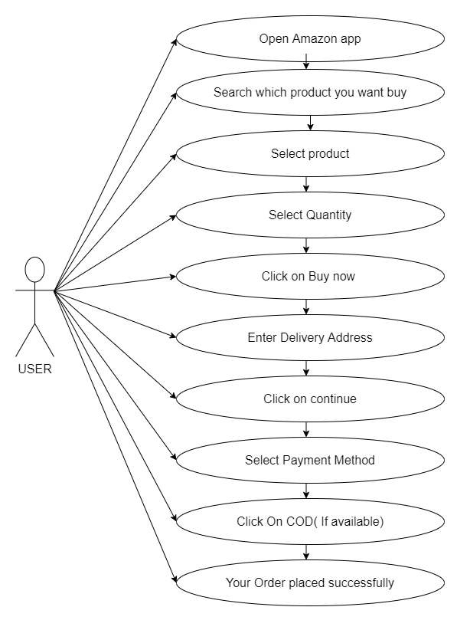

Que.> Draw usecase on online shopping product using payment gateway.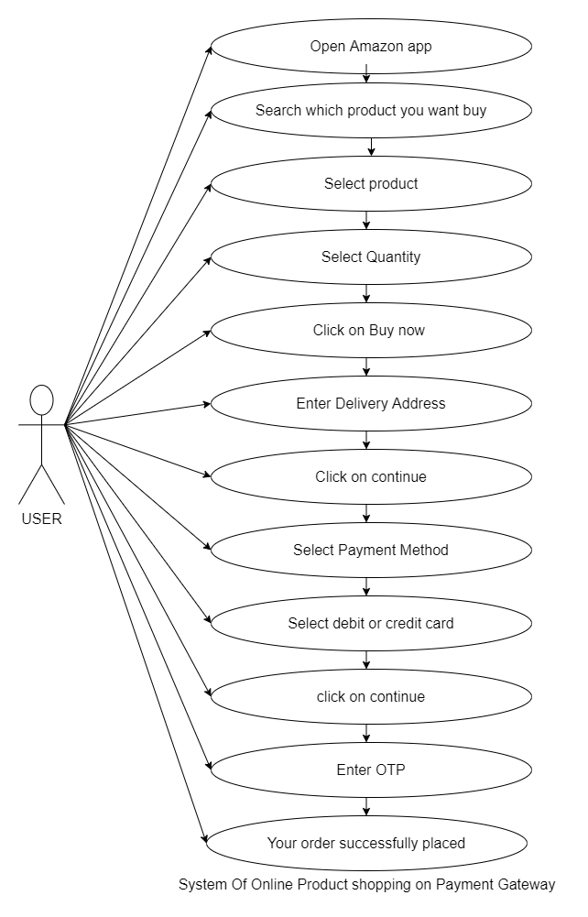

Que.> Draw usecase on online book shopping .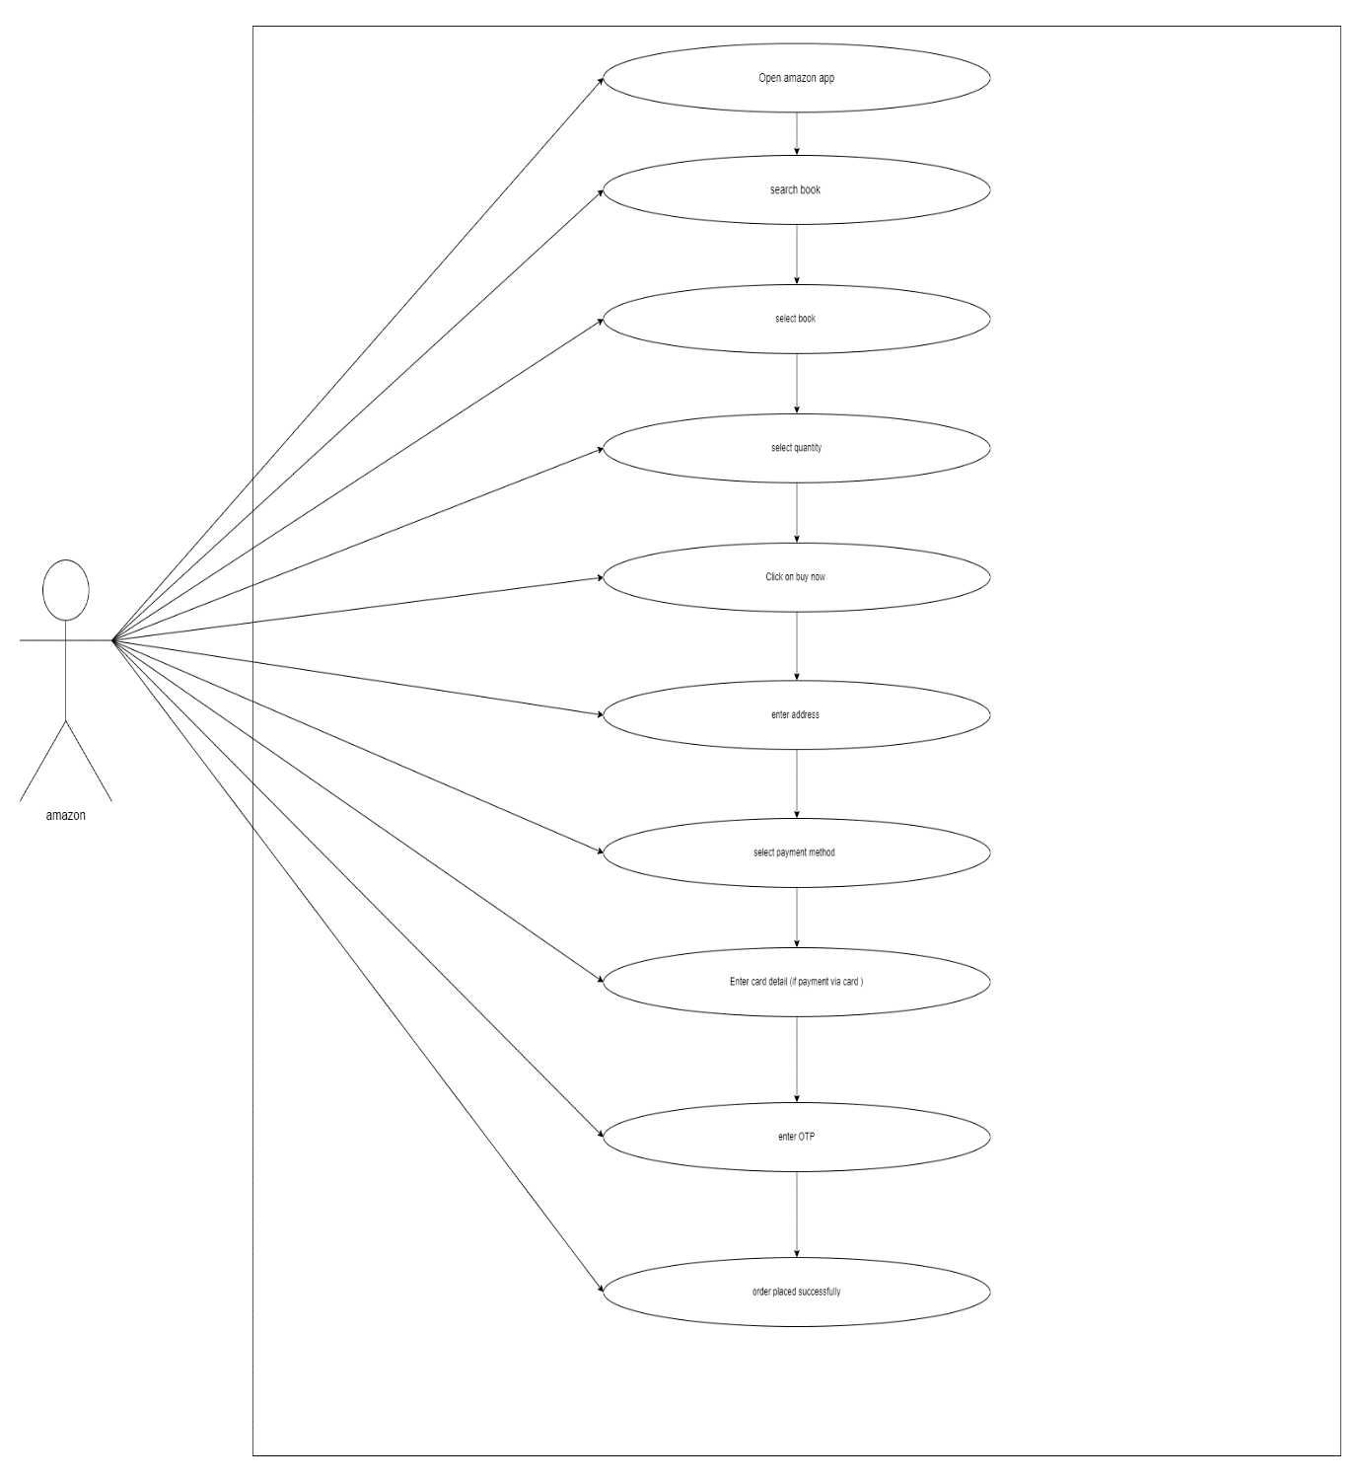

Que. > Draw use case on online bill payment system (paytm).